Parties, Weddings and Events
The Baxter Barn offers a rustic and charming place to:
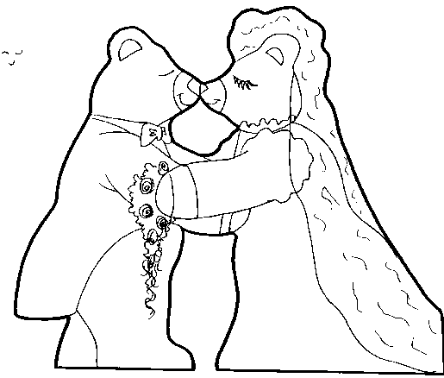

Host a Wedding

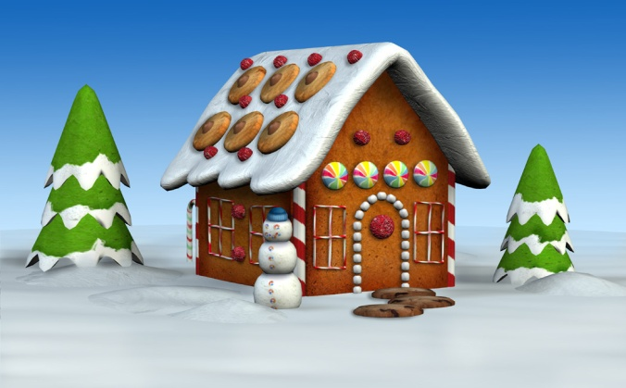
A Holiday or Christmas Party

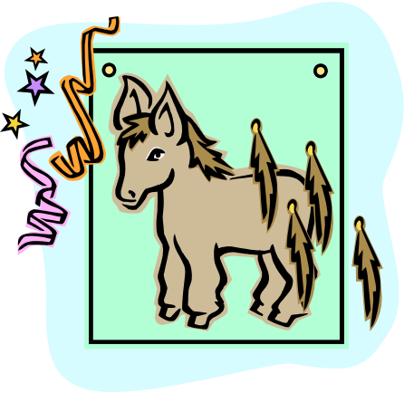
A Special Children’s (or adult) Birthday Party



or Special Event

The Baxter Barn also carries unique handmade gifts for all occasions.

